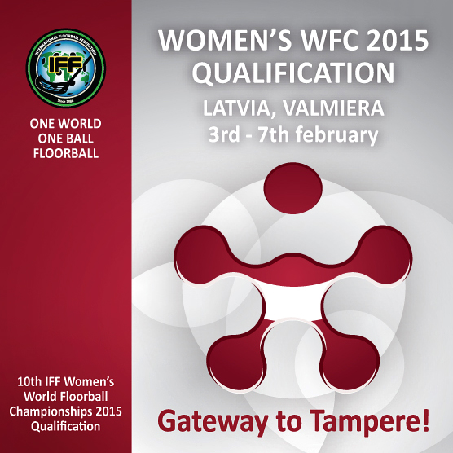
Media Accreditation Form
Women’s World Floorball Championships 2015 Qualification
Vidzeme Olympic Centre, Valmiera, Latvia
3rd – 7th February, 2015

Organization/Media Information
Organization/Media: …
Country: …
Address: …
Web page: …
Personal Information
First name: …
Family name: …
Function (Journalist / Photographer / TV / Radio): …
Mobile phone: …
E-mail: …

Please attach .jpg format portrait photo (preferred size: 800x1200 px, 300dpi) to your accreditation e-mail.

Send accreditation forms and photos to aris@floorball.lv . Accreditation deadline is January 25. Accreditation confirmation will be sent to your e-mail.

Media Contact: Āris Aldiņš (phone: +371 26073337, aris@floorball.lv)

